**Guide on how to check E-mail Size, Compact it and archive old e-mail**

It important to check your e-mail Size as problems can occur when the size limit has been reached. These problems can include slow working speed to crashes of outlook and eventually difficulty in starting it up. There are two options available if you are reaching this point which is either to delete old e-mail or Archive e-mail.

Deleting as the name applies is the removal of e-mail you may not need anymore. Achieving is the process of moving your e-mail to another location so not to disturb your active account. This can reduce your e-mail size without deleting your old e-mail.

Compacting your e-mail is the process whereby outlook’s free space is made after modification of e-mail amount in your outlook. This can reduce e-mail Storage size and is normally done automatically after a period by outlook, but can be forced by the user.

**How to check your e-mail size (active account only)**

On outlook 2010 go to File / Info / Cleanup Tools / Mailbox Cleanup

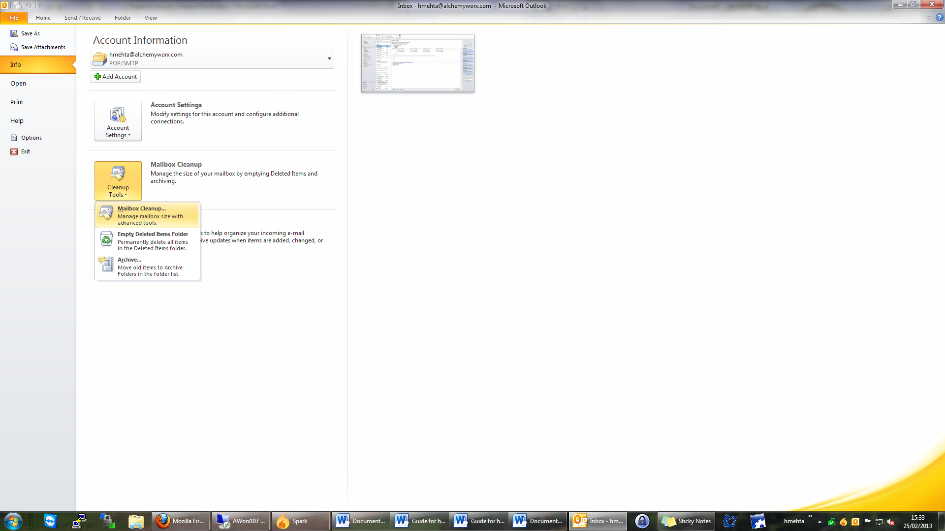

In outlook 2007 it’s Tool / Mailbox Cleanup

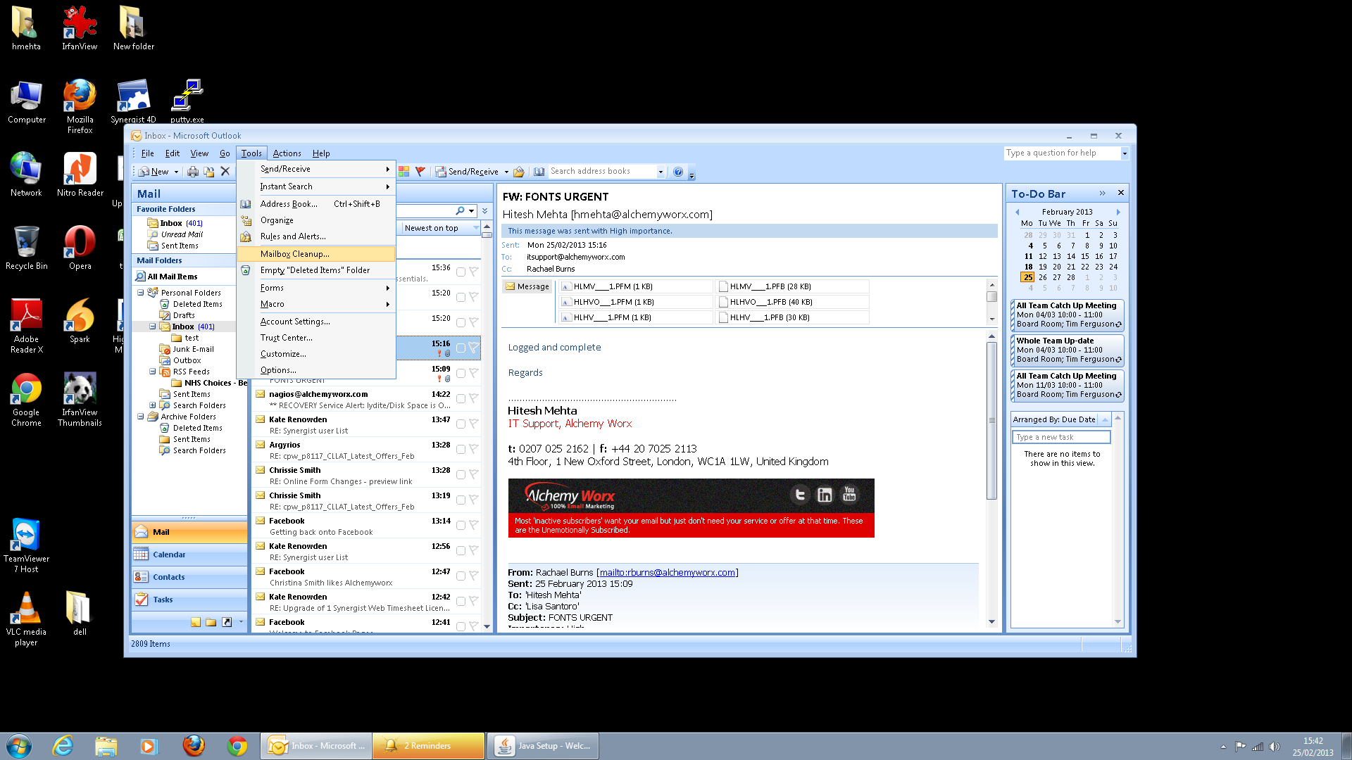

After pressing on “mailbox cleanup” in either of the Outlooks you should get the below left.

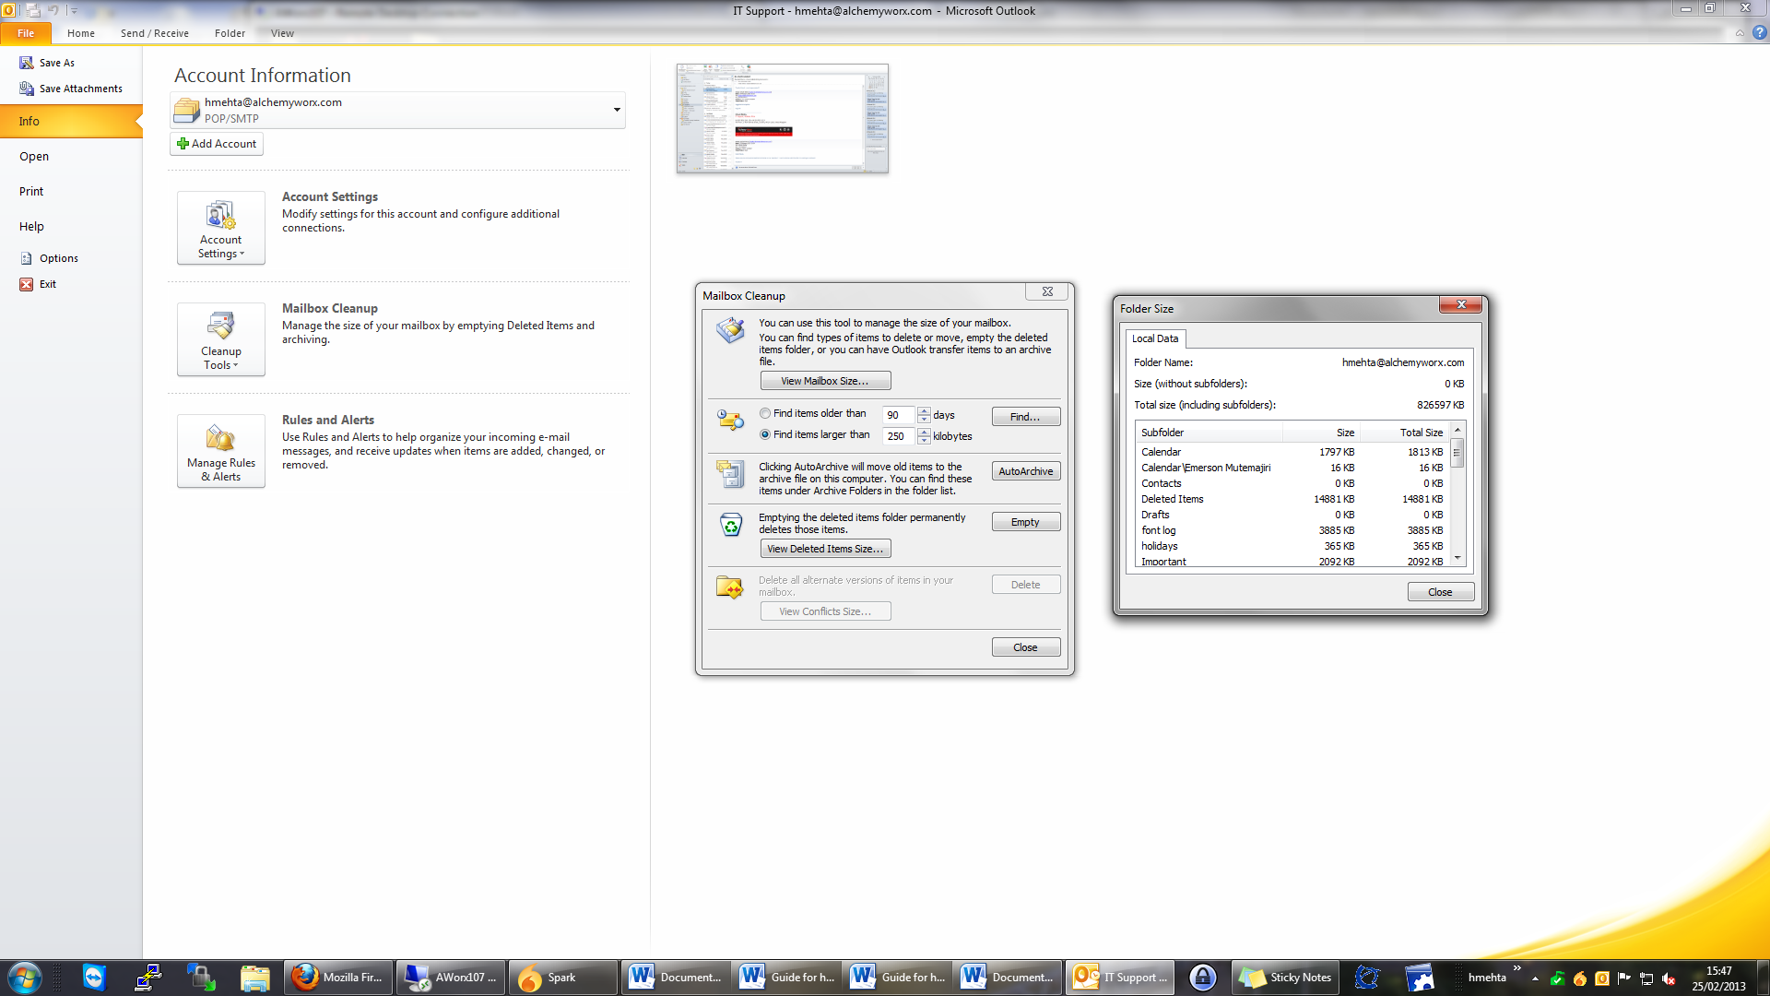

Press the “View mailbox size” and you should the window to the right with all your email size information. The total size is what you’re interested in although scanning the sub folders can help you find where space is being taken up most.

For outlook 2007 the limit is 20 GB and for outlook 2010 it is 50 GB. If the Total Size is close to these you may need to start deleting unwanted e-mail or archiving (the next guide).

If you experience problems reading the values the first 3 (from the right) account for a MB and the next for GB i.e. I have 826597 KB (total size) which is 826.597MB and 0.826597 GB.

**Archiving and Auto-Archiving**

In Outlook 2010 go to File / Mailbox Cleanup and Archive: 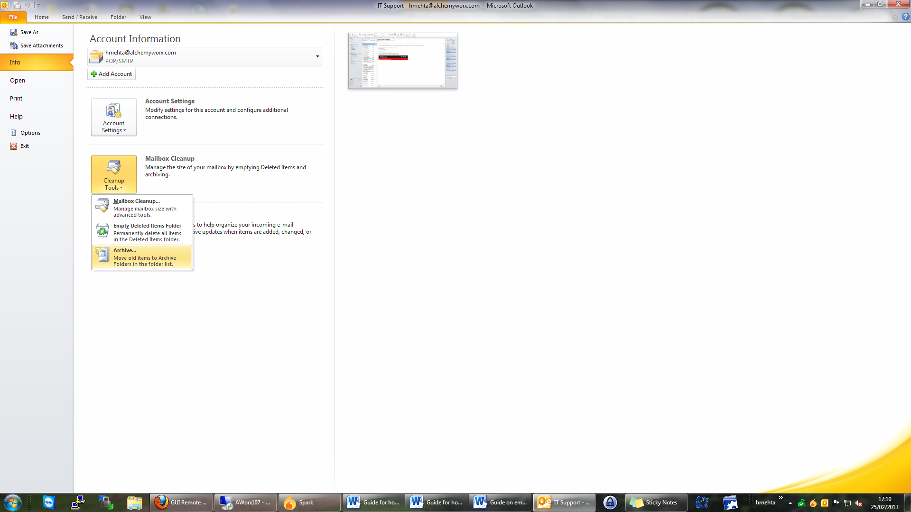

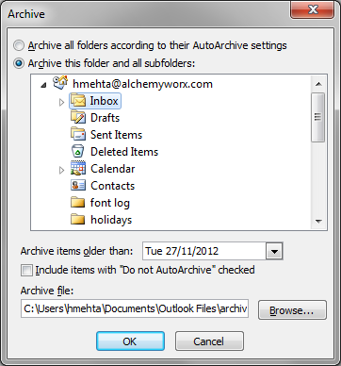In Outlook 2007 go to (left picture):

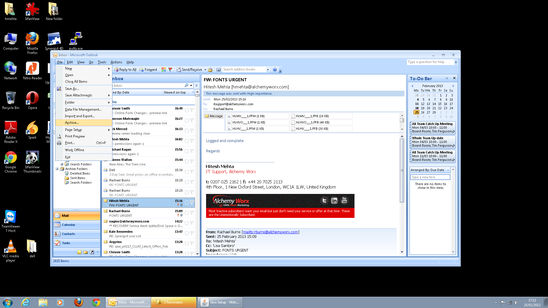

You will get the above right (outlook 2007 and 2010). Select from which folder you would like to archive and what period before.

Once all settings are chosen press ok and all the mail chosen is archived to a desired location (which can be added to later on as well). Be warned that if you have selected a large amount it may take some time to fully archive and may affect the speed of outlook.

To auto-Archive on outlook 2010 go to file / Option / advanced / Auto-Archive Settings and to auto Archive on outlook 2007 Tools / Options / Other / AutoArchive. The Following should be seen:

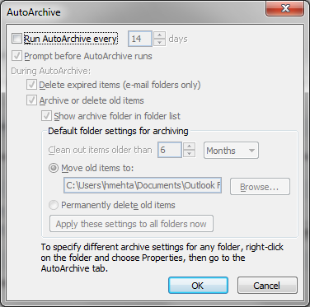

Set As you see fit and press ok. You can also force auto archive in the previous archive menu.

Checking archive e-mail size

Archives can also get filled up (has the same size limitation). To alleviate this you can simply create a new archive by changing the directory when creating the archive. To check the sizes of the archive do the following:

On Outlook 2010 go to

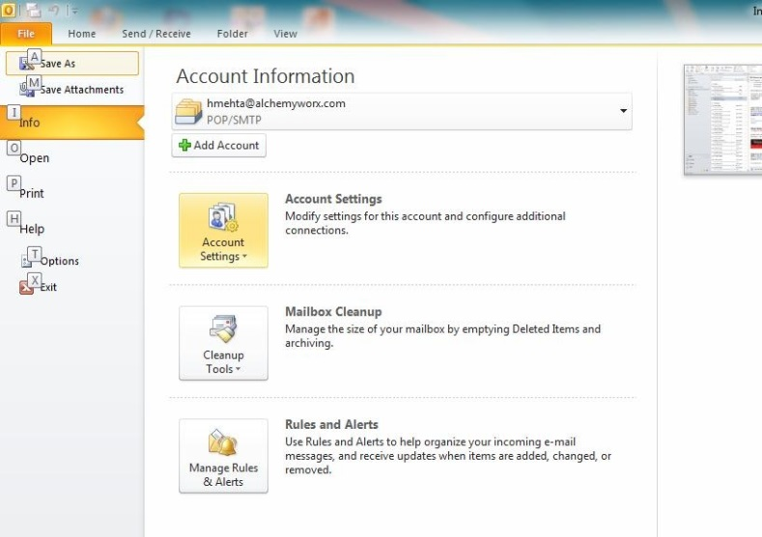

On outlook 2007 go to:

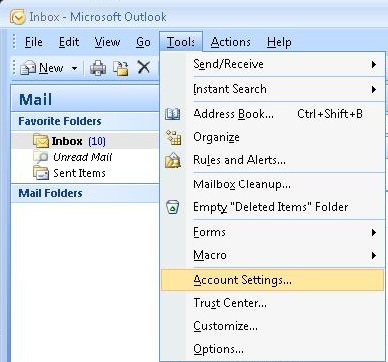

Go to Data files tab in here you will see all your main mail files (the one you receive e-mail in is the default one). Select the one you would to check and press the open folder button.

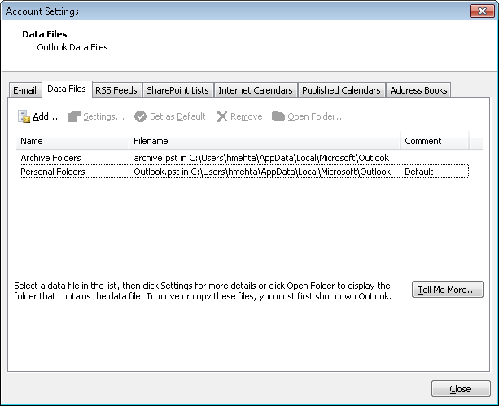

The below will open. The .pst files represent your mail Storages; the sizes next to them represent the sizes of your mail.

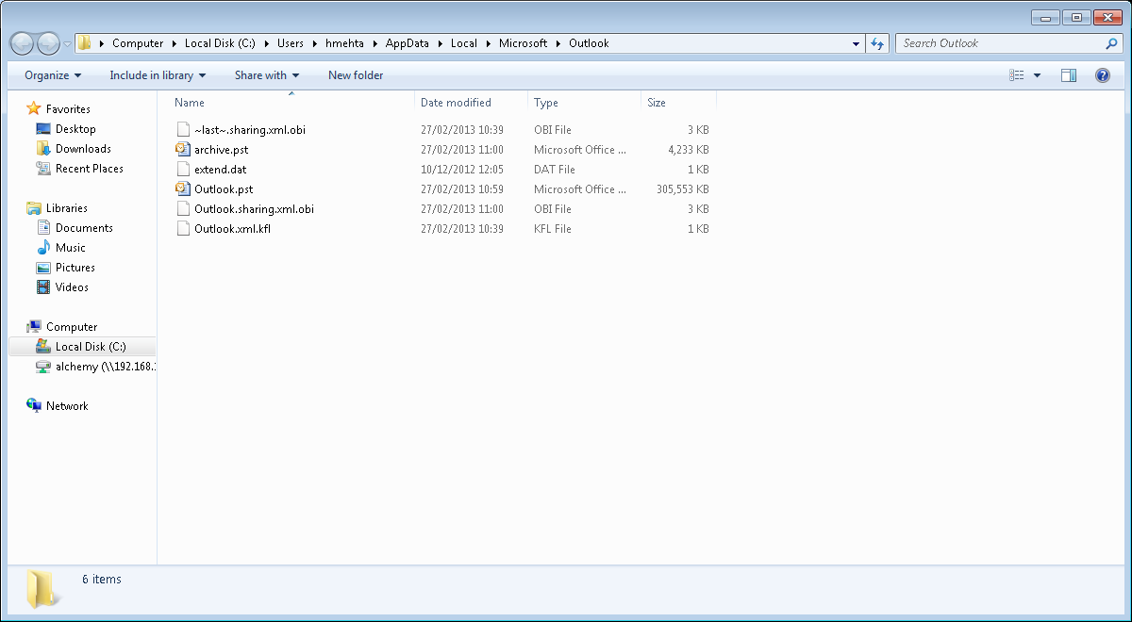

This method differs to the other method as it will also show how big your email storages are but it will not show you how big specific folders are in your current mailbox (or any other mail storage).

This is the main method for seeing archive size.

Compacting Your E-mail

Go to the account settings section again and then the Data files section, select the mail storage you just modified (it could be your main or one of the archives) and press Settings: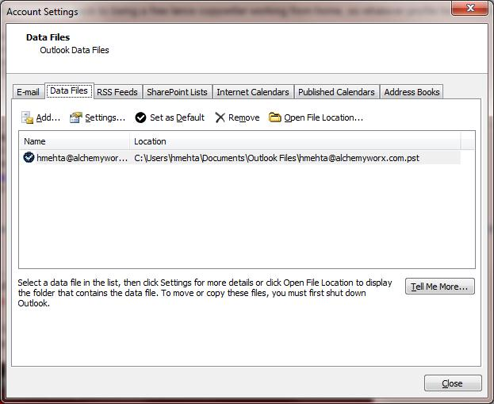

Then press Compact Now. **Please Note this is a lengthy process and may take a couple of hours if a lot of e-mail has been removed/modified, you will not be able to use your e-mail in this time.** It is suggested to run this overnight (please remember to lock your machine if you do this). 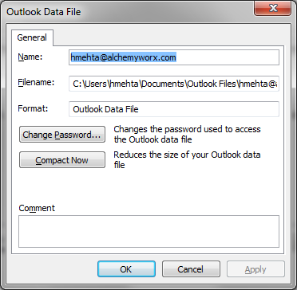

This sums up the main methods of e-mail size maintenance.